**TSA/TSRA COVID-19 Handbook**

The information in this handbook shall be treated as policy / procedure during the COVID-19 outbreak. TSA Management will notify all staff when the event has ended, and the requirements herein are no longer in effect.

Recent Updates

|  |  |  |
| --- | --- | --- |
| **Updated** | **Topic** | **Page** |
| 2/24 | Effective 3/1 – Gowns only required for High-Risk + AGP | 13 |
| 2/10 | Effective 2/22 – Facilities are no longer considered high-risk | 13 |
| 2/10 | Removed several outdated items |  |
| ~~1/27~~ | ~~All residents of SNFs & ALFs are considered high-risk~~ | ~~13~~ |
| 11/10 | Exhalation filter or procedure mask required for all respirators | 14 |
| 11/10 | Procedure/Surgical masks are required – NO cloth face coverings allowed | 1,3 |
| 10/22 | Screening Precautions Updated | 13 |
| 8/27 | Removed restriction on apneic oxygenation | 16 |
| 7/22 | Methylprednisolone (Solumedrol) ALLOWED | 16 |

*\* Links within the document don’t seem to work with Word Online. Open in Desktop App for links.*

Readiness

The organization will provide and ensure access to adequate training and education, cleaning and disinfection products, personal protective equipment, and employee guidance and support. The organization will communicate regularly with staff regarding changes in practices and expectations.

Team members will be aware of expectations for self-assessment and self-care and practice effective infection control procedures. Team members will ensure they obtain necessary training and education, an adequate amount of personal protective equipment, and seek support when needed.

Ambulances and equipment will be disinfected after each call and after each shift.

## **General Hygiene and Safety Practices**

* **Wash your hands as often as possible**
* Practice social distancing, six-foot distance from others when possible
* Employees must always wear a procedure or surgical mask in a Tri-State Ambulance building or vehicle
  + See Infection Prevention Guidance – Universal Mask Procedure
* Wear civilian clothes to work, change into uniform at work
* Wash uniforms after every shift

## **Shift Start**

* Employee belongings should be placed in the exterior compartment just behind the driver’s side door
* When clocking in on e-pro, complete the required screening form that appears to document you can work your scheduled shift.

## **TSA Facilities**

* Walk-up patients should be screened from a distance for signs/symptoms of ILI
  + If positive, take appropriate PPE prior to engaging in close contact with the patient (six feet)
* No guests or visitors in any TSA facility
* No tours or other special events until further notice
* Refrain from entering MedComm if there are other means of communicating with them
* Our stations have an abundance of surfaces which are touched by many people throughout the day. This includes hard surfaces such as tables, chairs, and computers as well as soft surfaces such as recliners and couches. It is strongly recommended that crews follow these guidelines to help protect themselves and others from the spread of this disease.
* Ongoing and off going crews should limit their time together to keep the number of simultaneous staff in crew quarters to a minimum.
* Complete disinfecting of crew quarters should be done multiple times per day. Crews assigned to a respective station are responsible to ensure this is happening.
* Once crew quarters are disinfected; visitors, including supervisors, managers, dispatchers, and others should not enter unless necessary. Power truck staff who expect to be at a station only briefly should consider limiting their entry into crew quarters.
* Upon any entry into crew quarters, the first action by staff should be to wash their hands well with soap and water.
* Keep in mind that once a station is disinfected, it is again contaminated when a surface is touched.

## **Admi****nistrative Issues**

* If you have any other concerns such as childcare, FMLA, compensation, future concerns, etc. Please call the Operations Supervisors or Administrative Director and we can help get you to the answers you need
* TSA has resources arranged in the event an employee is quarantined and needs to be away from family, please contact the Administrative Coordinator should this need arise
* All sick calls must go to Shift Supervisor, followed by a call to Employee Health Services at 775-7569.

Universal Mask Procedure

**Updated 11/10 (Effective 4/7)**

Employees must always wear a procedure or surgical mask in a Tri-State Ambulance building or vehicle. Exceptions include when donning an N95 or respirator and when eating or drinking. Employees must always wear a mask while on shift and entering a public or private facility. This includes refueling, stopping for food, etc.

## Availability of Masks at Start of Shift

Obtain a new procedure/surgical mask at the beginning of each shift. A box of masks will be available at each timeclock. These masks are to be used only for start of shift and should not be used to restock ambulances or for personal use outside of work.

## When to Doff Mask for Reuse

Reuse of a mask is acceptable only when doffing for eating or drinking. Dispose of the mask if doffing it while assigned to a call (switching to N95 or respirator).

## To Doff Mask with Intent to Reuse

1. **Perform hand hygiene**
2. Remove mask
   1. Remove procedure mask by holding the ear loops. The front is potentially contaminated, so remove slowly and carefully.
   2. Remove surgical mask by untying lower ties FIRST. Untie upper ties last. The front is potentially contaminated, so remove slowly and carefully. Ensure ties do not fall into clean interior side of mask.
3. After removing facemask, visually inspect for contamination, distortion in shape/form. If soiled, torn, or saturated the mask should be discarded.
4. If the facemask is NOT visibly soiled, torn, or saturated, carefully store **exterior side down on a paper towel.**
5. **Perform hand hygiene.**

Universal Mask Procedure Continued…

## To Re-Don Mask

1. **Perform hand hygiene**
2. Grasp mask
   1. Pinch procedure mask at the ear loops or
   2. Grasp upper ties on surgical mask
3. Place over face
   1. For procedure mask: Secure ear loops behind the ears. Secure mask.
   2. For surgical mask: Secure upper ties first, behind head. End by securing lower ties behind head.
4. **Perform hand hygiene**

A disposable facemask can be worn throughout your shift if not visibly soiled, torn or saturated, and NOT touched while delivering patient care.

## Conservation of PPE

Tri-State Ambulance has an adequate, but not inexhaustible, stock of masks. To maintain supply, conservation of masks is essential. To ensure masks remain available throughout the pandemic, please follow the outlined procedures for mask use and re-use.

## Rationale for Universal Mask Use

As knowledge of this pandemic illness grows, it has become more apparent that pre-symptomatic/asymptomatic transmission is a likely mode of transmission. Universal mask use serves the following purposes:

1. Protects our patients and coworkers should we have pre-symptomatic or asymptomatic infection or develop symptoms at work.
2. Protect ourselves in the event we come into close contact a patient or other healthcare worker with pre-symptomatic or asymptomatic infection.

## Principles for Success

To ensure success and safety, we must be steadfast in the following principles:

1. Strict adherence to the extended use and reuse of masks
2. Meticulous adherence to hand hygiene
3. Proper masks use – including wearing it over mouth and nose
4. Avoidance of manipulation/touching the mask to reduce the risk of contamination

Universal Mask Procedure Continued…

## FAQ

**Can I use my procedure or surgical mask between patients, including those with ILI?**

Yes. Use the guidelines above which ensures careful and deliberate handling of the mask to prevent both self-contamination and cross contamination.

**Does the Universal Mask Procedure apply to all Tri-State Ambulance employees?**

Yes. This practice applies to all employees in a common area. Bedrooms and offices are not considered common areas but should be disinfected frequently.

**Does the Universal Mask Procedure apply to Patient Care Hub (MedComm) employees?**

Yes. Maintain physical distancing as possible when interacting with PCH employees.

Physical Distancing

**Added 6/23**

When doffing a face covering for eating, drinking, or breaks, strict adherence to physical distancing is required. Maintain at least six feet from anyone who is not wearing a face covering.

Response Operations

## **Dispatch**

Public Safety Answering Points (PSAPs) may screen for influenza-like illness (ILI) prior to handoff to GHS Medical Communications (MedComm) Emergency Medical Dispatch (EMD). Regardless of that, EMD will perform screening of 911 callers for ILI and provide that information to responding ambulance crews and if previously agreed upon, PSAPs and/or first response agencies.

**Current EMD Practice (6/23/20)**

All calls will be screened through the EIDS tool. MedComm will provide a “High-Risk Precautions” or “Low-Risk Precautions” notification upon completion of the screening process.

## **At-Scene**

Upon arrival at scene, EMS personnel will don High-Risk Precautions designated PPE if “ILI Precautions” or “High-Risk Precautions” notification was provided by MedComm.

If no “Risk Precautions” information was provided, EMS personnel shall perform a screening from at least six feet away when possible. Any responder not involved in patient care activities shall remain at least 10 feet away from the patient.

Patients shall be screened as “High-Risk Precautions” or “Low-Risk Precautions” and appropriate PPE shall be donned based on specific criteria found in the “Patient Screening & PPE” section of this document.

A procedure mask shall be immediately placed on all patients if able to be tolerated.

Individuals riding along with the patient shall not be allowed unless there is an end-of-life concern or the patient is a minor and requires a parent. In this case, one person may ride along and shall be asked to don a mask. If asked about hospital restrictions on visitors, advise the individual that they should call before leaving for the hospital to determine current guidelines of that facility.

## **Transport**

The driver shall safely doff their gown and gloves and perform hand hygiene prior to entering the cab of the ambulance. The driver shall continue to wear eye protection and mask/N95 or respirator. The patient care provider(s) shall continue to wear all PPE previously donned.

Airflow in the ambulance shall minimize risk of contamination and maximize elimination of any airborne particulates.

If there is a need to increase the level of PPE, the ambulance shall pull over, the driver shall obtain an appropriately fitted N95 or respirator for the patient care attendant(s), and the attendant(s) shall don the respirator outside the ambulance.

Notify the receiving hospital using standardized verbiage and provide radio report as early as possible.

Transport PPE

|  |  |  |  |
| --- | --- | --- | --- |
| **Driver** | | **Patient Care Provider(s)** | |
| **MASK OR RESPIRATOR** | **EYE PROTECTION** | **MASK OR RESPIRATOR** | **EYE PROTECTION** |
| **GOWN** | **GLOVES** |

Airflow in Cab

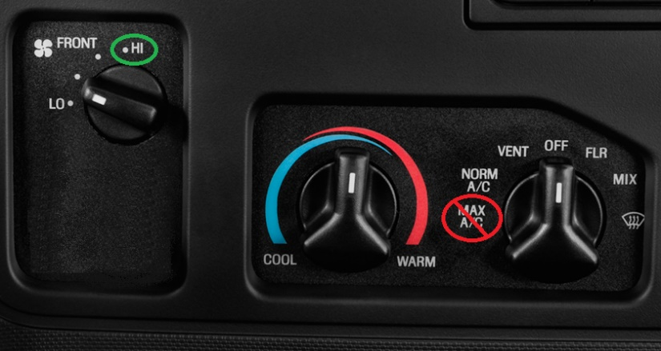

Airflow in Patient Compartment

Inter-Facility Transfers

#### Neonate Transports

* For neonate transfers, the cot and isolette should be transported through the employee door located to the right of the ambulance bay entrance. Crews will need to park the ambulance and then walk around to the door to assist the neonate team with the cot

## **Arrival**

The driver must don gown and gloves prior to opening doors to patient compartment. Patient care providers shall not open doors.

Attempt to minimize close contact with other healthcare providers and patients while transiting through hallways.

Maintain full PPE except when instructed otherwise below.

Gundersen Health Systems – La Crosse

**Emergency Services Transports & Direct Admits**

Pass through designated entrance and meet guide in ambulance bay. Follow guide to destination. Remove dirty linen in patient room. Doff gown and gloves in patient room or anteroom and perform hand hygiene. Don clean gloves in patient room and exit.

[Direct Admits Only] Perform gross disinfection of cot in hallway away from other healthcare personnel and/or patients.

Follow guide back to ambulance bay and designated area to disinfect cot. A single disposable gown will be provided by GHS for ambulance disinfection.

See below or click here.

Mayo Clinic Health Systems – La Crosse

**EUCC Transports**

Low-Risk Precautions patients will enter through the ambulance garage and normal EUCC entrance.

High-Risk Precautions patients will enter through the ambulance garage, immediately turn right, and proceed to the second set of doors to your left. Doff gown and gloves in patient room or anteroom and perform hand hygiene. Don clean gloves in patient room and exit.

Proceed to ambulance garage to disinfect ambulance and cot.

**All Direct Admits**

Enter through ambulance garage, immediately turn right, and walk to furthest set of doors on left (near bathrooms). All direct admits should have security and/or nursing escorts.

**High-Risk Precautions Direct Admits**

Remove dirty linen in patient room. Doff gown and gloves in patient room or anteroom and perform hand hygiene. Don clean gloves in patient room and exit.

Perform gross disinfection of cot in hallway away from other healthcare personnel and/or patients.

Return to ambulance garage, find non-disposable gown in cabinet, and don for disinfection of ambulance. Perform full disinfection of cot and ambulance. Place soiled non-disposable gown in linen hamper.

** Patients with aerosol generating procedures may have respiratory staff meeting crews in the ambulance bay to assist in transport to destination room.

Vernon Memorial Healthcare - Viroqua

**Normal flow for all patients**

waiting room door and waiting room to designated section of ER as directed.

Crossing Rivers Healthcare – Prairie Du Chien

**Normal flow for all patients**

Gundersen Palmer Lutheran Healthcare – West Union

There are currently no changes for entering GPLH. In the future, there may be a designated RED entrance for High-Risk Precautions and GREEN entrance for Low-Risk Precautions.

University of Wisconsin – Madison

See below or click here.

St. Mary’s Hospital in Rochester

4/13/2020 In order to minimize contamination through the hospital, they are instituting an immediate practice change that will require an escort to navigate all EMS personnel with direct admissions, to the floor and ICUs, throughout the transfer within the hospital. The garage registration staff at SMH ED will coordinate with hospital escort, through EPIC, to meet EMS upon arrival and therefore navigate the environment, I.e. doors, elevators, ICU access, minimizing the risk of contamination. The hospital is requesting EMS services to call report when they are 30 minutes out, if possible, so staff can alert the escort.

## **Disinfection**

Thorough disinfection of cot, equipment, and ambulance shall be performed after each transport of a patient with High-Risk Precautions. Disinfectant spray or wipes shall be used, and surfaces shall remain wet with disinfectant for required timeframe found in “Directions for Use” on package. If unsure of timeframe, surfaces shall remain wet for three minutes.

Conservation of PPE shall be considered when performing disinfection procedures. Whenever possible, PPE worn during patient contact shall be used during disinfection.

Disinfection of cot shall be performed while wearing mask/N95 or respirator, eye protection, and gloves.

Disinfection of ambulance shall be performed while wearing mask/N95 or respirator, eye protection, gown, and gloves.

### Reuse of N95 Masks

There are two red bins in all ambulances. The purpose of these bins is for you to safely store an N95 during shift for use on multiple calls. These bins will vary in location based on ambulance design. Please take time at the start of your shift to identify its location.

Current recommendations allow for multiple uses of an N95 if it is used by the same provider and there’s no visible signs of the mask being soiled.

There are also repositories at each station for you N95s at the end of shift. Management will be collecting used N95s and disinfecting in accordance with CDC guidelines.

Patient Screening & PPE

Screening for precautions should occur both through the dispatch process and at least six feet away from the patient. If dispatch information includes any of the High-Risk Precautions criteria, don High-Risk Precautions PPE prior to making patient contact.

|  |  |  |  |  |  |  |  |  |  |  |  |
| --- | --- | --- | --- | --- | --- | --- | --- | --- | --- | --- | --- |
| **Criteria for High-Risk Precautions**  **Assess from Six Feet Away**   |  | | --- | | **Patient or Close Contact Had COVID-19 Test in Last 14 Days (Regardless of results)** |   **OR**   |  | | --- | | **Unresponsive/Unable to**  **Answer Questions Reliably**  **(Do not rely on 3rd party answers)** |   **OR**   |  |  | | --- | --- | | **ANY of the Following** | | | **Fever ≥ 100.4° F (37.8° C)** | **Loss of Sense of Taste or Smell** | | **Shortness of Breath** | **New Respiratory Problems1** | | **Chills** | **Cough** | | **PPE for High-Risk Precautions**   * **N95 or Respirator** * **Face Shield or Sealed Goggles** * **Gloves** * **Procedure mask on patient** * ***Gown is optional unless AGP*** |
| **PPE for High-Risk w/ AGP**   * **High-Risk Precautions plus** * **Gown** |
| **PPE for ALL Other Patients**   * **Surgical/Procedure Mask** * **Gloves** * **Eye Protection**   + **Safety glasses or face shield** * **Procedure mask on patient** |
| 1. **New Respiratory Problems:** persistent sneezing, wheezing, congestion, etc. | |
| **Transport Ambulances & LCFD**  In addition to the normally required information for each respective alert or radio report;   * If a patient is screened **into inclusion**, the EMS provider must report **“High Risk Precautions”** when contacting MedComm for all Stroke, STEMI, and Trauma Alerts and in all radio reports. * If a patient is screened **out of inclusion**, the EMS provider must report **“Low Risk Precautions”** when contacting MedComm for all Stroke, STEMI, and Trauma Alerts and in all radio reports.   For Alerts: MedComm will include precautions in their report/page to the receiving facility/teams. | |

Patient Care PPE

|  |  |
| --- | --- |
| **LOW-RISK WITH NO AEROSOL GENERATING PROCEDURES\*** | **HIGH-RISK AND ALL AEROSOL GENERATING PROCEDURES\*** |
| **GOWN** | **GOWN** |
| **PATIENT WEARS PROCEDURE MASK IF POSSIBLE** | |
| **SURGICAL OR PROCEDURE MASK (NOT N95)** | **N95 OR RESPIRATOR\*\*** |
| **EYE PROTECTION** | **EYE PROTECTION** |
| **GLOVES - GOWN TUCKED INTO GLOVES** | **GLOVES - GOWN TUCKED INTO GLOVES**  **(CONSIDER SECOND PAIR)** |
| **\* Aerosol generating procedures include nebulized medication administration,**  **CPAP, BIPAP, airway management (including BVM), and CPR. Avoid if possible.** | |
| **\*\* All respirators must have exhalation filter installed or**  **A procedure mask covering the exhalation port.** | |

# **Clinical Practices**

**Modified 7/22**

## Intubation Allowed for Approved Providers

* Effective this week, providers who have received face shields and been signed off & approved to intubate can do so. Approval is provided by Nick for TSA providers and Walt for TSRA. Sleeve type gloves will also be distributed to airway management kits and are expected to be used for intubation to prevent gross contamination of the intubator’s arms.

**Updated 4/16**

## Enhanced PPE For All Cardiac Arrests

* All personnel operating within six feet of a cardiac arrest must be in **Aerosol Generating Procedures Precautions PPE.**
* Consider placing non-rebreather mask to prevent aerosol/spray prior to placement of supraglottic airway.

**Added 4/2**

## Ventilator Use for Critical Care IFT

* When swapping ventilators during critical care IFTs, be sure to assess for presence of closed suction and bacterial/viral filter on ETT. If there is no suction and filter, clamp the ETT and pause their ventilator prior to disconnecting circuit. Failure to clamp ETT and pause their ventilator will result in aerosolization and potential spraying of secretions.
* Additionally, strongly consider placement of closed suction at the time of swap to prevent additional disconnects.
* Hemostats on order – for now will have to ask for one at facility.
* <https://www.youtube.com/watch?v=HD_oyqnlNdQ>

**Added 3/30/2020**

## Removal of NIPPV for High-Risk Precautions Patients

* It is recommended that High-Risk Precautions patients transported with NIPPV in place be switched to a non-rebreather mask prior to exiting the ambulance and entering the receiving facility. Place a procedure mask over the NRB mask.

# **Clinical Practices Continued…**

**Added 3/14/2020 – Last Modified 8/27/2020**

## ~~Intubation Suspended~~

* ~~Except in extraordinary circumstances (i.e. supraglottic airway does not work), performance of intubation is suspended. Any patient requiring airway management should have an i-gel or King Airway placed. To prevent aerosolization of oral secretions, BVM ventilation should be performed for as short a period of time possible – move to airway placement ASAP. This applies to ALL patients, not just those with suspected ILI.~~
* ~~All airway management should be done with appropriate PPE including eye protection, mask (surgical or procedure – not N95), and gloves. Any airway management with a High-Risk Precautions patient MUST have eye protection, N95 or respirator, gown, and gloves.~~

## **Removed 8/27** ~~Apneic Oxygenation Modified~~

* ~~Performance of apneic oxygenation during RSI is modified due to risk of aerosolization of oral secretions. A nasal cannula MAY be placed at 6L/min instead of 15L/min but it is not necessary.~~

## A Filter Must Be on the Airway Prior to Placement

* A bacterial/viral filter must be placed on the airway PRIOR to placement. Filters will be placed in each of the intubation kits.
* The ETCO2 sampler should be placed distal to the filter as there is no viral filter within the sampler. This MAY impact the reading. Be conservative if making any changes to treatment based on the ETCO2 value. In the current setting, the goal of ETCO2 monitoring is primarily for verification purposes.

## **Removed 7/22** ~~Do Not Administer Steroids~~

* ~~Methylprednisolone should not be administered to ANY patients as part of the asthma/COPD guideline.~~

## Limit Use of Nebulizer – Use Mask

* Administration of nebulized medications should only be done after very thoughtful consideration. It is preferred to use a mask for delivery of nebulized medication and to place a surgical or procedure mask over top. An N95 or respirator should be worn by care providers while nebulized medications are administered.
  + Nebulized medication administration should be done in an open area if possible.
  + Nebulized medication administration should be discontinued prior to entering a healthcare facility.

Documentation

**This section added 4/2**

## Documentation of PPE Use

* Documentation of PPE use is required for all calls.

**Updated 4/16 (live in afternoon)**

## Verbal Consent for High-Risk Precautions Patients/Representatives

* For patients with High-Risk Precautions, verbal consent may be obtained from the patient.
* If the patient is physically or mentally incapable of signing, verbal consent may be obtained from a representative who is considered High-Risk.
* Follow the guidelines below for collecting verbal consent.

Patient is High-Risk Precautions but would normally sign for themselves

If the patient is a known or suspected COVID-19 patient and is physically or mentally capable of signing, *you may sign on the patient’s behalf* after obtaining verbal consent.

To do so:

* Select the **High-Risk Billing Patient Signature w/ Verbal Consent** signature
* Select **EMS Crew Member (Other)** or **EMS Primary Care Provider (for this event)**
* Select the appropriate **Crew Member/Name**
* Ensure patient is aware of billing/NPP statements and obtain verbal consent – click Accept
* Write above the line the following **“[Patient Name] by [Crew Member Name] per verbal consent.”**
* Sign your name on the line.

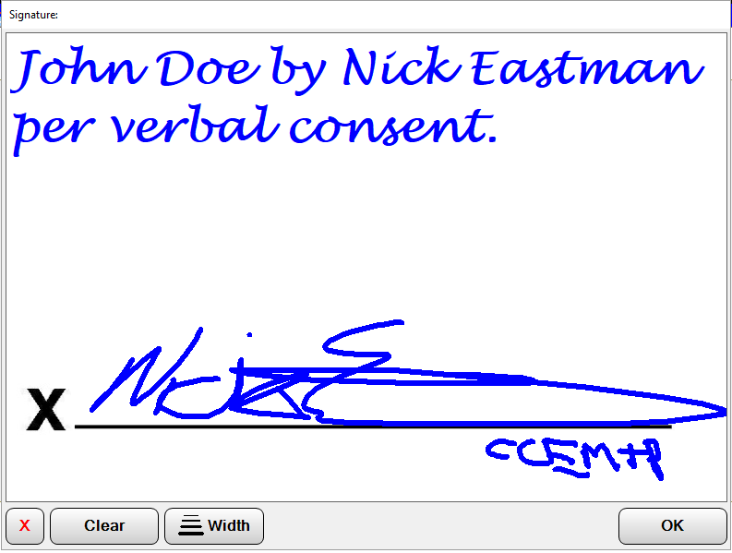

Patient is incapable of signing and representative is High-Risk

If the patient is physically or mentally incapable of signing and the representative is a known or suspected to have COVID-19, *you may sign on the representative’s behalf* after obtaining verbal consent.

To do so:

* Select the **High-Risk Billing Representative Signature w/ Verbal Consent** signature
* Select **EMS Crew Member (Other)** or **EMS Primary Care Provider (for this event)**
* Select the appropriate **Crew Member/Name**
* Ensure representative is aware of billing/NPP statements and obtain verbal consent – click Accept
* Write above the line the following **“[Representative Name] by [Crew Member Name] per verbal consent.”**
* Sign your name on the line.



|  |  |
| --- | --- |
| **LOW RISK** | |
| ***Emergency Services &* *Direct Admit***  No escort to or from department | |
| **HIGH RISK**  *No Aerosol* | **HIGH RISK w/ AEROSOL**  *(CPAP/BiPAP, Nebulizer, Airway, CPR)* |
| ***Emergency Services***   * No escort to or from department * Strip cot of dirty linen in patient room * Doff gown & gloves in patient room * Perform hand hygiene * Don clean gloves in room * Move cot to and obtain gown and cleaning supplies in ambulance bay | ***Emergency Services***   * No escort to or from department * Strip cot of dirty linen in patient room * Doff gown & gloves in patient room * Perform hand hygiene * Don clean gloves in room * Move cot to and obtain gown and cleaning supplies in ambulance bay |
| ***Direct Admit***   * No escort to or from department * Identify clean hands person (typically driver)   **Clean Hands Person**   * Perform hand hygiene * Don clean gown and gloves * Disinfect foot end/handle of cot * Doff gloves * Perform hand hygiene * **DON CLEAN GLOVES** * Place clean sheet over patient   **Full Crew**  **(after transfer of care)**   * Strip cot of dirty linen in patient room * Doff gown & gloves in patient room * Perform hand hygiene * Don clean gloves in room * Move cot into ante room/hallway * Perform gross disinfection of cot * Move cot to ambulance bay & obtain gown and cleaning supplies * DO NOT don clean gown with dirty gloves * Disinfect cot & equipment in designated area | ***Direct Admit***   * Meet escort from admitting unit staff to provide “clean hands” * Place clean sheet over patient * Maintain full PPE including respirator mask and follow escort to unit   **Full Crew**  **(after transfer of care)**   * Strip cot of dirty linen in patient room * Doff gown & gloves in patient room * Perform hand hygiene * Don clean gloves in room * Move cot into ante room/hallway * Perform gross disinfection of cot * Move cot to ambulance bay & obtain gown and cleaning supplies * DO NOT don clean gown with dirty gloves * Disinfect cot & equipment in designated area |



|  |  |  |  |  |  |
| --- | --- | --- | --- | --- | --- |
| **PPE use** Suspected/confirmed COVID patients   |  |  | | --- | --- | | * Gloves * Gown | * N95, respirator, or PAPR * Face shield or goggles |   Non-COVID suspected patients— but delivering direct patient care (within 6 feet of patient airway)   * Gloves * Face shield or goggles * Surgical/procedure mask   Please do not bring patient’s family/friends with on transport. If no alternatives exist, patient’s family/friend will be screened at the ED entrance.  **EMS arrival workflows – non-COVID patients**  **For patient transfers or transports to EDs or direct admit to University Hospital, TAC or AFCH**   * No change from current state, except visitor guidelines   **EMS arrival workflows – COVID-confirmed or suspected patients *(changes effective 4/1/2020)***  **For transfers of confirmed or suspected COVID patients brought to University Hospital, TAC or AFCH**   * When calling report to ED or inpatient unit, please share if patient is on any oxygen support:  |  |  | | --- | --- | | * Nasal cannula * High flow nasal cannula * Non-rebreather * Nebulizers | * CPAP * BiPAP * Vented * Trached | | * If patient condition will tolerate transitioning from   high flow nasal cannula/CPAP/BiPAP to non-rebreather mask from the ambulance to their patient room, please do so.   * Additionally, if patient will tolerate a simple surgical mask over face (including airway mask) please put into place prior to entering hospital.   **Adult or pediatric ED transports to TAC or University Hospital (also to the pediatric ED)**   * Call University Hospital ED charge RN via radio and offer ETA and radio report * Please use ED EMS entrance * Room assignment will be posted on electronic tracking board (as possible) * ED staff will assist EMS in finding room   **For adult University Hospital direct admits (also see map)**   * Do not go to ED entrance with direct admits * Call ACCESS Center (1-800-472-0111) to be connected to receiving unit (F6/5, D6/5, TLC) * EMS to share updated ETA * A resource COVID RN and staff member will meet EMS at C4/3 (Old ED— see map) to escort patient and crew to receiving unit * UW Health team members will walk EMS to unit, wiping down door handles and surfaces after being touched   **For pediatric AFCH direct admits (also see map)**   * Go to ED entrance with direct admits * Call ACCESS Center (1-800-472-0111) to be connected to receiving unit (PICU, NICU, P5, P7) * EMS to share updated ETA * A resource COVID RN and staff member will meet EMS at ED entrance to escort patient and crew to receiving unit * UW Health team members will walk EMS to unit, wiping down door handles and surfaces after being touched |



**EMS direct admit patient drop-off**

Includes possible and confirmed COVID adult and pediatric patients

ED

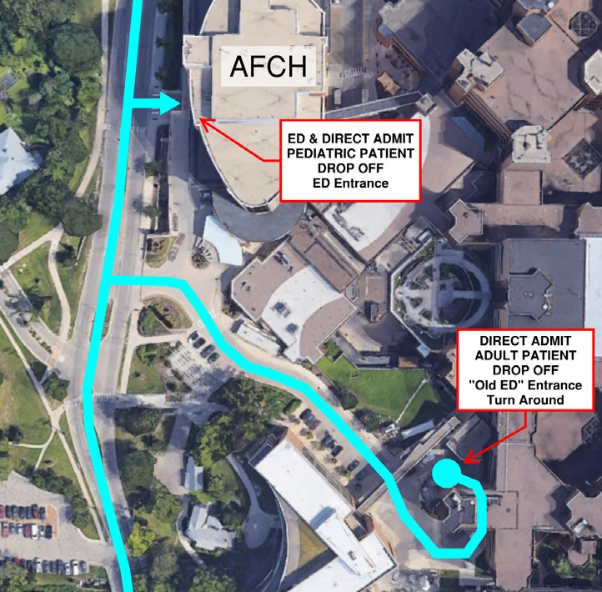

**Pediatric direct admit use ED EMS entrance**

**Adult Direct admit use old ED entrance**

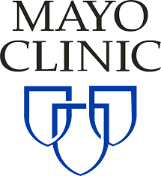

**St. Mary’s Hospital – Rochester**

ALL EMS personnel with direct admissions will require an escort. Garage registration staff will coordinate with hospital escort. Call report 30 minutes from destination to ensure that they are ready for your arrival.